What is Cleansing Stream?
Cleansing Stream is a discipleship ministry that is designed to identify, define and then help to establish key Biblical truths that are vital to every follower of Jesus living life the way God intended. Being a Christian is described in scripture as “brand new”, “being moved from darkness to light”, “the old passing away – the new arriving”, “living life abundantly”. Cleansing Stream introduces the believer in a very practical, step by step approach to that brand new way of living life as we follow Jesus.
The Cleansing Stream Seminar, which is run through the local church, establishes key truths from God’s Word that are the foundation for a follower of Jesus Christ to live life the way God intended. The teaching nights often include a small or home group component to them which adds to the relational dynamic of the seminar. With that Biblical foundation established, participants then continue through the course by attending a Cleansing Stream Freedom Day which is led by Cleansing Stream leadership and attended by yours and other churches from your region.
Cleansing Stream is about finding “freedom for your journey”. Wherever you are on your Christian journey, the course can help you live your life in Christ to the fullest.

If you commit your heart and mind to the Lord for this 10- week process, no doubt your life will be changed!

“For I know the plans I have for you,” declares the Lord, “plans to prosper you and not to harm you, plans to give you hope and a future.
Jeremiah 29:11

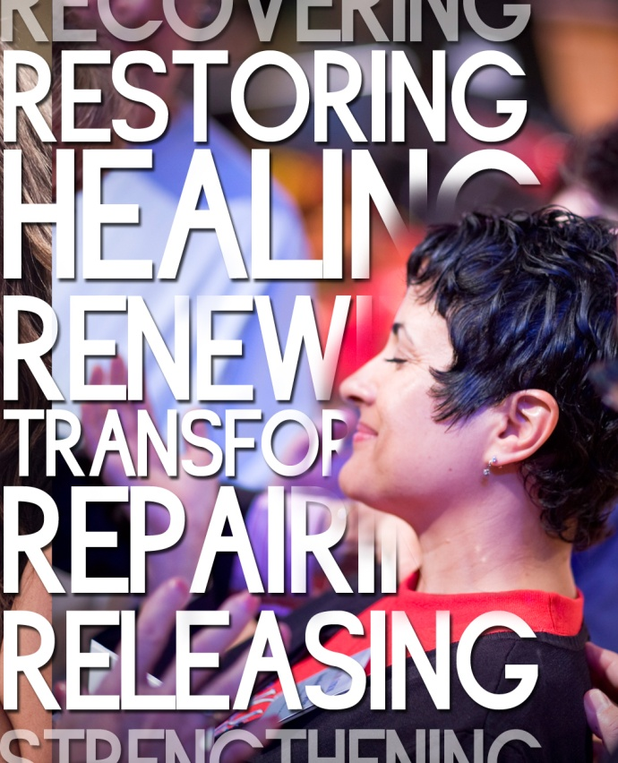
Cleansing Stream
Material & Freedom Day
Cost

Class Materials:

Individual Workbook
$45.00

Optional Seminar Audio Teaching
$40.00

Optional Seminar Reading Book
The Bait of Satan – John Bevere
$25.00

Freedom Day
$60.00

Materials must be paid for in advance!
(Payment can be made in 2 installments
– ½ at registration, ½ at first class)

Please make cheques payable to:
Your local church
For CSM information, contact:
Your contact persons name Ph xxxxxxx or
email@yourchurch.org.nz

www.cleansingstream.org.nz

Cleansing Stream
Seminar & Freedom Day

AUTUMN 2019

Your Local Church
Your church address
Your town
