CLEANSING STREAM
SEMINAR & FREEDOM DAY
Schedule - Autumn 2019

Tuesday 7:00 – 9:00 pm

FREEDOM DAY PREPARATION CLASSES:
21 May:
Session 1 – Knowing the Father

28 May:
Session 2 - Walking in the Spirit

4 June:
Session 3 – Committing Everything to God

11 June:
Session 4 - Speaking Words of Life

18 June:
Session 5 – The Bait of Satan (if you offer this)

18 June:
Session 6 - Entering the Cleansing Stream

25 June:
Session 7 - Pressing Toward the Goal

CLEANSING STREAM FREEDOM DAY
Saturday 22 June
9 AM – 5 PM
at
Tauranga

Freedom Day payment:
$60.00 due _________

Registration Deadline:
Sunday, 12 May, 2019
Please hand in Registration form and
FULL Payment of materials.

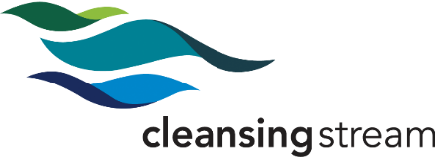

Seminar Registration

Name: ____________________________________________________________

Spouse's Name_____________________________________________________
(if attending)

Address:_____________________________________ Suburb:_________________ Post Code: ___________

Home Phone: __________________ Work Phone: _________________________ Cell: _______________________

E-Mail: _____________________________________________________________________________________________________

Home Church: _________________________________________

Prior to attending the Freedom Day, I commit:

To view the six main teaching session videos.
To complete the associated homework.
To follow through with my Cleansing Stream financial obligations

Following the Freedom Day:

To view the seventh main teaching session video and complete the associated homework.

Signature: ______________________________________________________ Date: ________________________

Spouse's Signature: _______________________________________________ Date: ________________________
(if attending)

Pastor's Approval: ________________________________________________ Date: ________________________
(If you are a part of another church, please have your pastor sign.)

